TO: ALL EMPLOYEES FROM: ANNE GRIFFITH

RE: AAA MEMBERSHIP PROGRAM DATE: JULY 10, 2026

We have arranged to provide employees with discounted rates for membership in AAA. Your AAA membership will be effective September 30, 2026. For current members the discount represents savings of $5.00 for Classic Primary membership (normally $59.00). New members will save an additional $20.00 off new membership dues (normally $79) because AAA is waiving the $20 enrollment fee. You must reside within the AAA East Central (club 215) service area.

The annual open enrollment period ends July 24, 2026 and the enrollment form below should be completed and returned to my office by that date. If you are already enrolled through this group program, your renewal is automatic and you do not need to complete an enrollment form. Payroll deductions will be made on August 14, 2026.

If you are already a member of AAA East Central (Club 215), AAA will simply extend your expiration date to September 30, 2027.
You pay a pro-rated amount based on the discounted rates and retain the full number of years you have been a valued member of AAA.
 | Classic AAA Membership - Covers you for basic roadside assistance, free maps, TourBooks, TripTiks and all kinds of AAA savings on hotels and restaurants, at stores, online and more. And, free Identity Theft Protection!
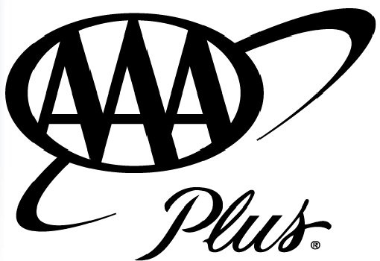 | AAA Plus Membership – Get all the basic AAA membership benefits plus:  Up to 100 miles of extended distance towing  Free fuel delivery – to get you to nearest service station  Extended Extrication and Lockout Services  AAA Plus RV – All the benefits of AAA Plus, extended to cover your eligible motorhome, travel trailer,  boat trailer, and other qualifying vehicles. (AAA Plus required for AAA Plus RV)
 | AAA Premier – The Utmost in AAA Benefits and services offering the highest level of protection including:  Extended towing up to 200 miles – 1 call per year/per household  Free concierge service  $1,500 Trip Interruption coverage  And much more! (AAA Plus required for AAA Premier)

QUESTIONS? CONTACT YOUR AAA REPRESENTATIVE GALE LUCAS AT:

(740)772-6815 OR LUCAS.GALE@ACE.AAA.COM

AAA GROUP MEMBERSHIP PROGRAM FOR EXISTING AND NEW AAA MEMBERS
(Circle one)

Company Name __________________________________HIGHLAND COUNY AUDITOR_______________________________________
Employee Name _____________________________________________ Date of Birth ____________________Phone #_____________________
Address ____________________________________________________ City/State/Zip Code__________________________________________
E-mail Address :_______________________________________________ AAA Card # _______________________ Exp. Date _________________

Eligible family members: Spouse or one adult age 18 and older, and dependent children through age 25 are $36 each.
All age 16-18 Associate members are Junior Associates and are free until age 19.

1)________________________________Date of Birth______________ 2)________________________________ Date of Birth______________
3)________________________________Date of Birth_______________ 4)________________________________ Date of Birth______________

_______ Yes, I would like AAA Classic ______ Yes, I would like AAA Plus
($54.00) (additional cost $39.00 Primary, $14 each Associate)
OFFICE USE ONLY

_______ Yes, I would like AAA Plus RV ______ Yes, I would like AAA Premier
(additional cost $40.00, must have AAA Plus) (additional cost $40.00, must have AAA Plus)

I authorize payroll deduction for my membership dues. _____________________________________________________
Signature/Date existing2026

